A MINI PROJECT REPORT

ON

“EDUCART”
In partial fulfillment of the requirements for the Degree of

Bachelor of Technology - CSE
By
ISHWIK VASHISHTHA
(Roll No. 2301270100051)
Submitted
To:
Dr A.P.J. ABDUL KALAM TECHNICAL UNIVERSITY

LUCKNOW


Under the guidance of
Mr. Neeraj Kumar Gupta
(Assistant Professor)
To the
Department of Computer Science & Engineering
(IIMT Engineering College, Meerut)

(Session 2024-2025)

CONTENTS

TOPICS | PAGE NO.
INTRODUCTION | 3
OBJECTIVE | 4
SYSTEM OVER VIEW | 5
WORKFLOW EXPLANATION | 6
FEATURE AND FUNCTIONS | 7-9
TECHNICAL ARCHITECTURE | 9-10
IMPLEMENTATION DETAILAS | 10-11
PROJECT RESULTS | 12
CONCLUSION AND FUTURE SCOPE | 13

Educart – A College Notes Sharing Platform

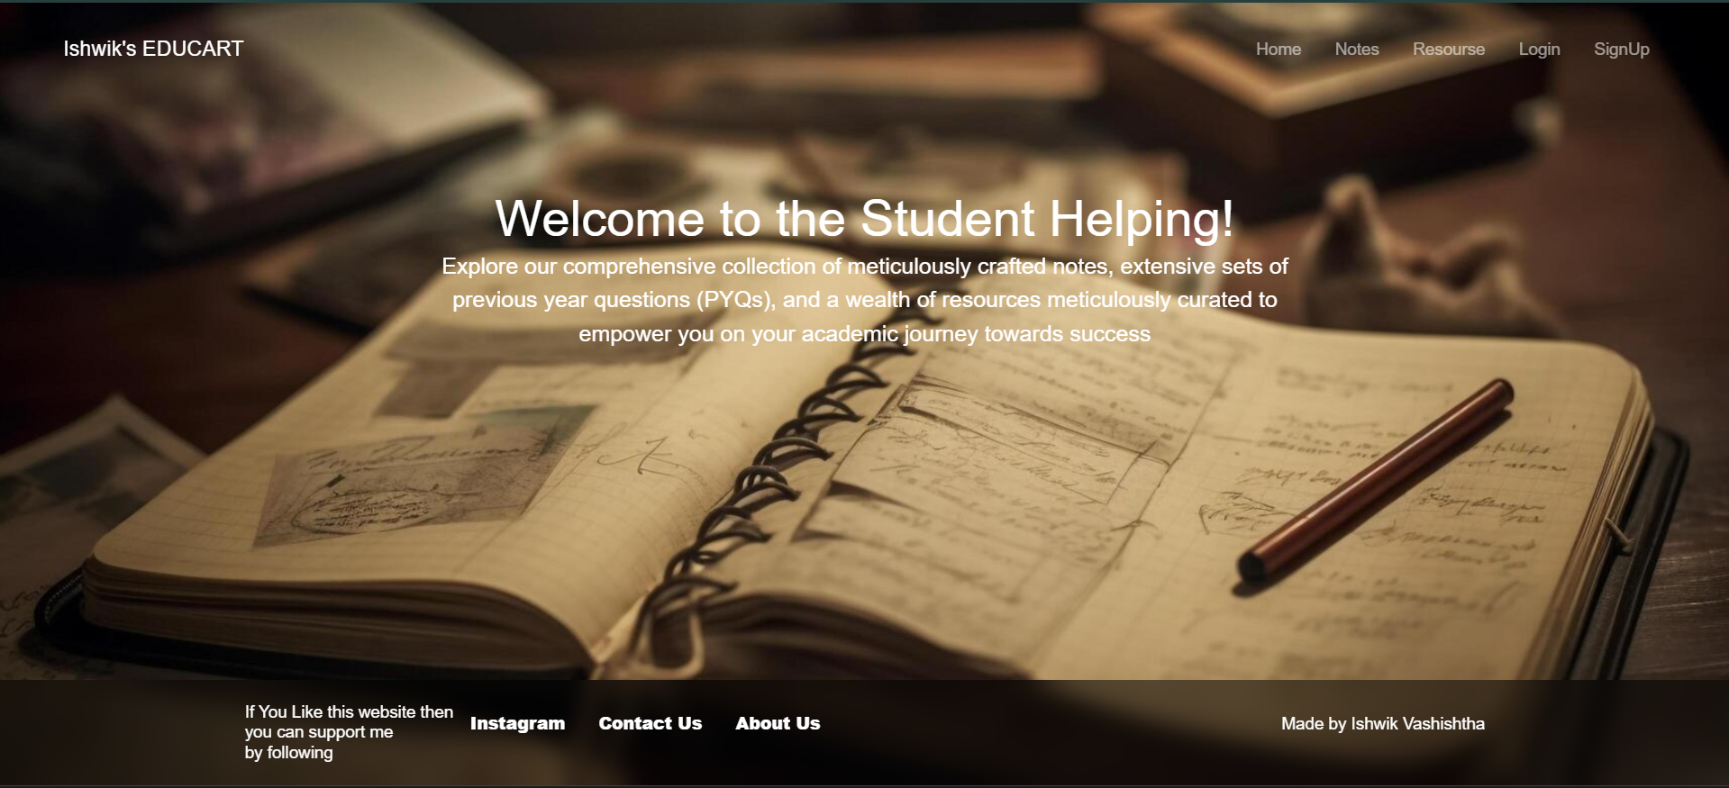

Introduction

Educart is a web-based platform designed specifically for college students. The website offers a centralized repository where students can upload, download, and manage notes for every subject corresponding to their current semester. The idea behind Educart is to save students time by eliminating the need to search through multiple external sources (like YouTube or disparate websites) for accurate and up-to-date study materials.

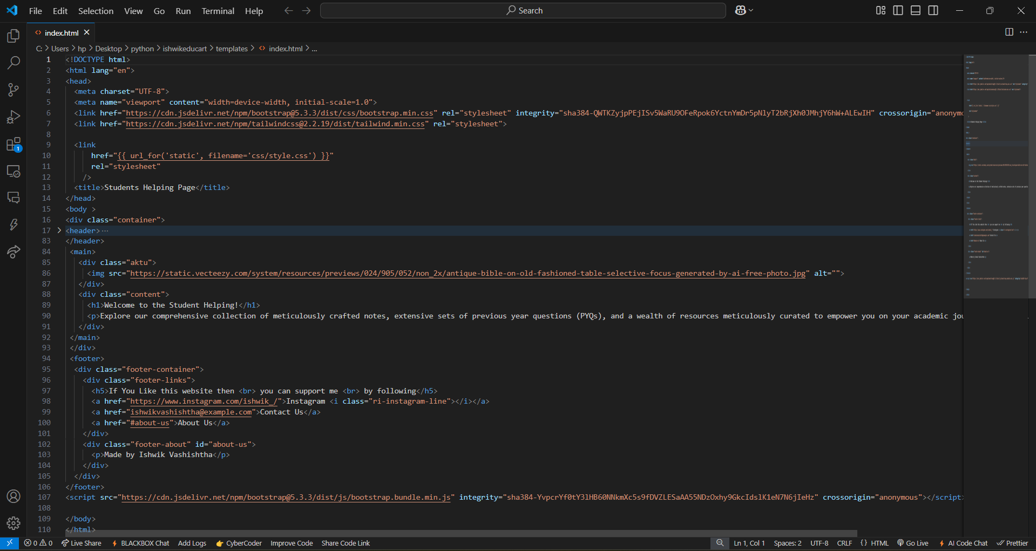

2. Project Objectives

Centralization of Study Material:
Provide a single, easily accessible portal for all college notes, reducing the time students spend hunting for study materials.

User Empowerment:
Enable users to contribute by uploading their own notes and update or delete content as needed, thereby keeping the repository current and relevant.

Enhanced User Experience:
Streamline the process of signing up, signing in, and searching for notes by subject and year, ultimately simplifying students’ academic workflow.

System Overview and Workflow

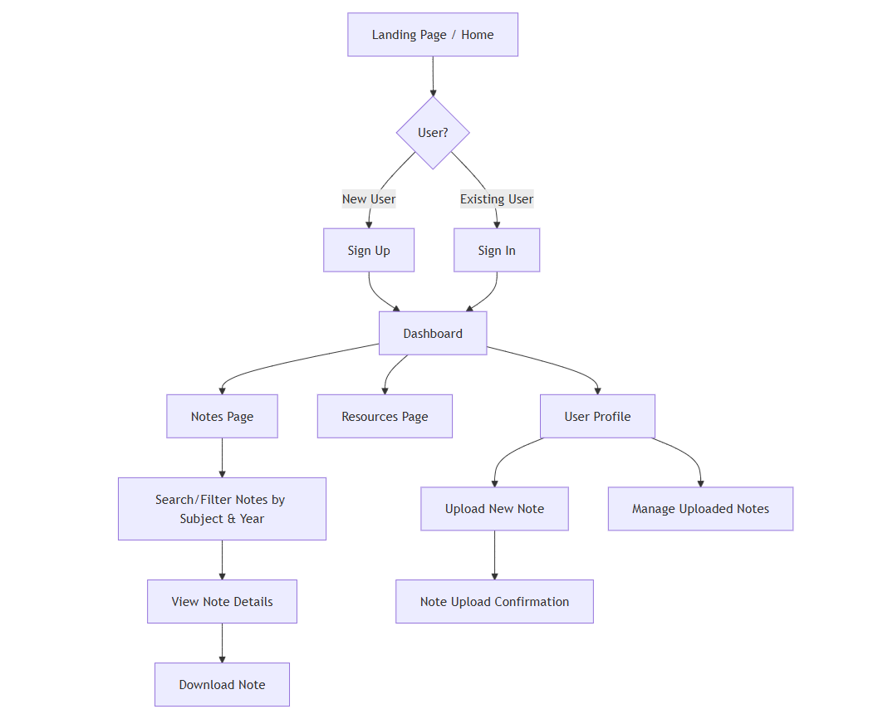

Diagram Explanation

Landing Page / Home (A): Users land on the homepage.

User Authentication (B):

New users go to sign up (C).

Existing users sign in (D).

Dashboard (E): After authentication, users reach the dashboard.

Navigation: From the dashboard, users can go to:

Notes Page (F): Where they can search/filter for and download notes.

Resources Page (G): For additional study materials.

User Profile (H): Here, users can now upload new notes and manage their existing uploads.

Uploading Notes:

From the User Profile (H), users select "Upload New Note" (L), which leads to a confirmation (M).

They can also manage (edit/delete) their uploaded notes directly from their profile (N).

The Educart website is designed with a clear and straightforward user flow:

Landing Page (Home):

Visitors land on a welcoming homepage that highlights the platform’s purpose.

User Authentication:

New users sign up while returning users sign in to access personalized features.

Notes Management:

Once authenticated, users can upload new notes, download existing notes, or delete their own uploads.

A search functionality enables users to quickly locate notes by specifying the subject and the corresponding academic year.

Additional Resources and Profile:

The platform includes dedicated pages for “Resources” (extra study materials, guidelines, etc.) and “User Profile” (to manage personal information and contributions).

4. Features and Functionality

User Registration and Authentication:
Secure sign-up and login processes ensuring that only verified users can upload or download content.

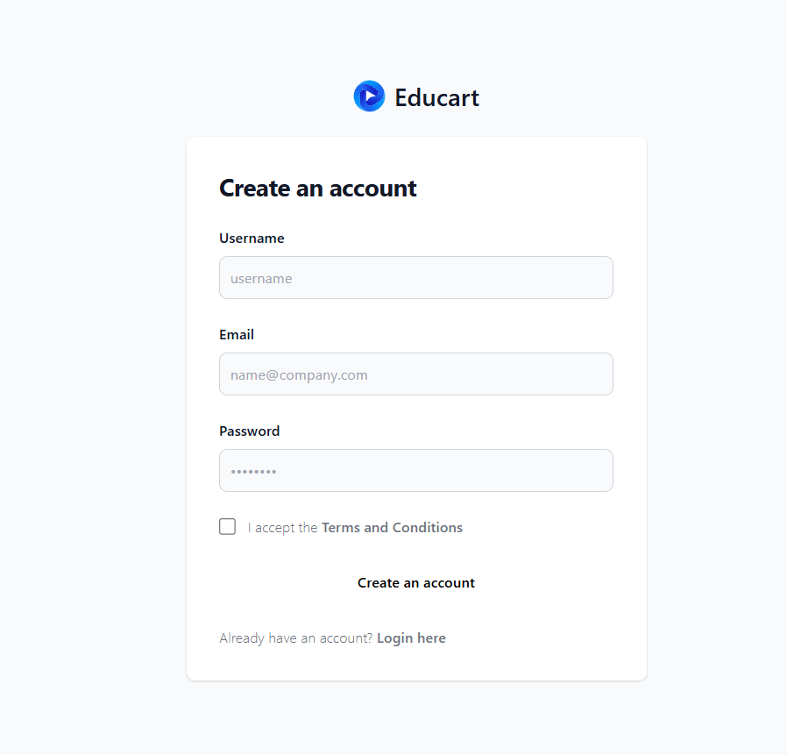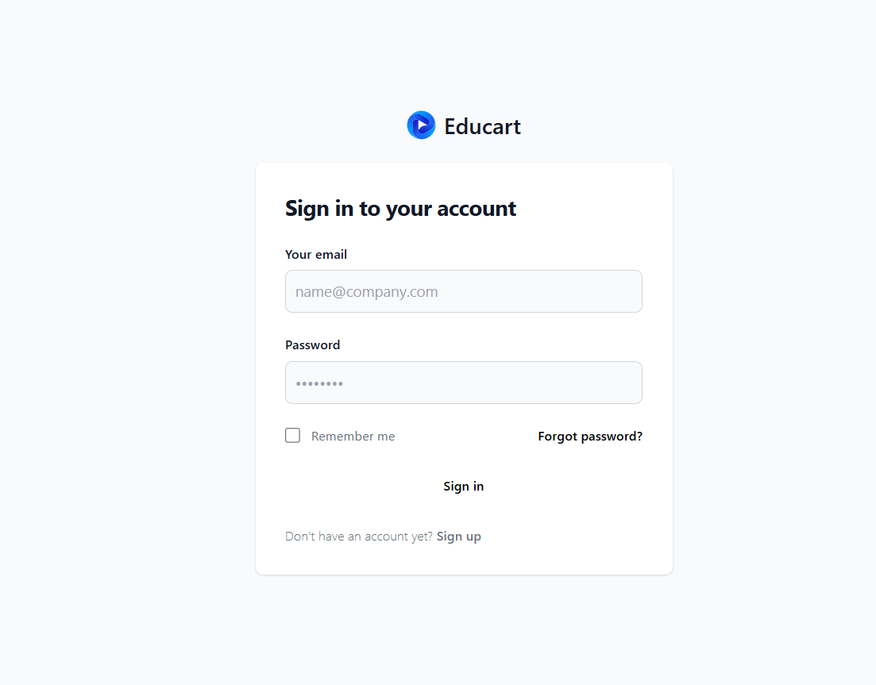

Upload and Download Capabilities:

Upload: Users can contribute notes with an intuitive upload interface.

Download: Students can search and download notes easily using filters (subject and year).

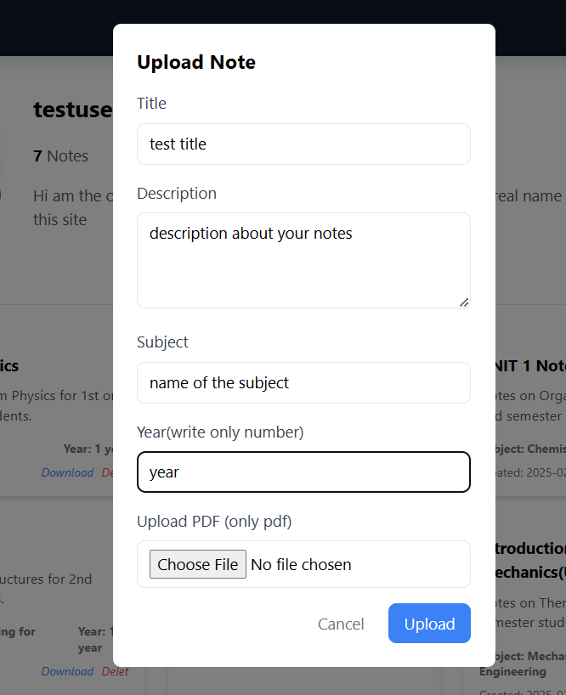

Search and Filter Syste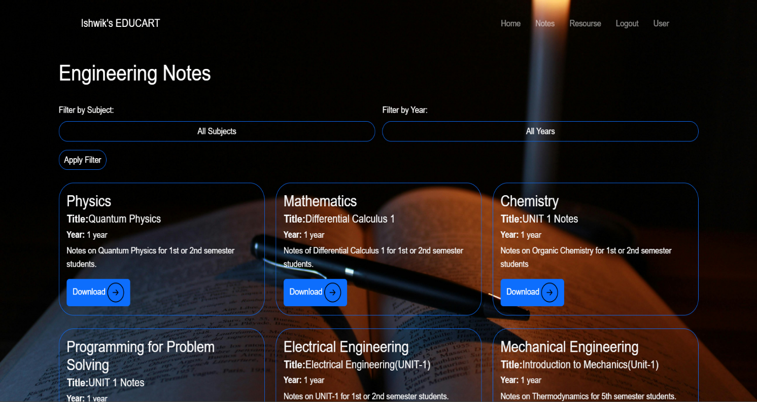

A powerful filter feature that lets users pinpoint the exact study materials they require.

Content Management:

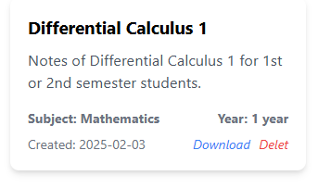
Users have the ability to delete or update their uploaded notes, ensuring that the content remains accurate and up-to-date.

Page Structure:
The website is divided into four main pages:

Home: Introduction and general information.

Notes: Central repository for study materials.

Resources: Additional study aids and educational content.

User Profile: Personal account management and history of uploads/downloads.

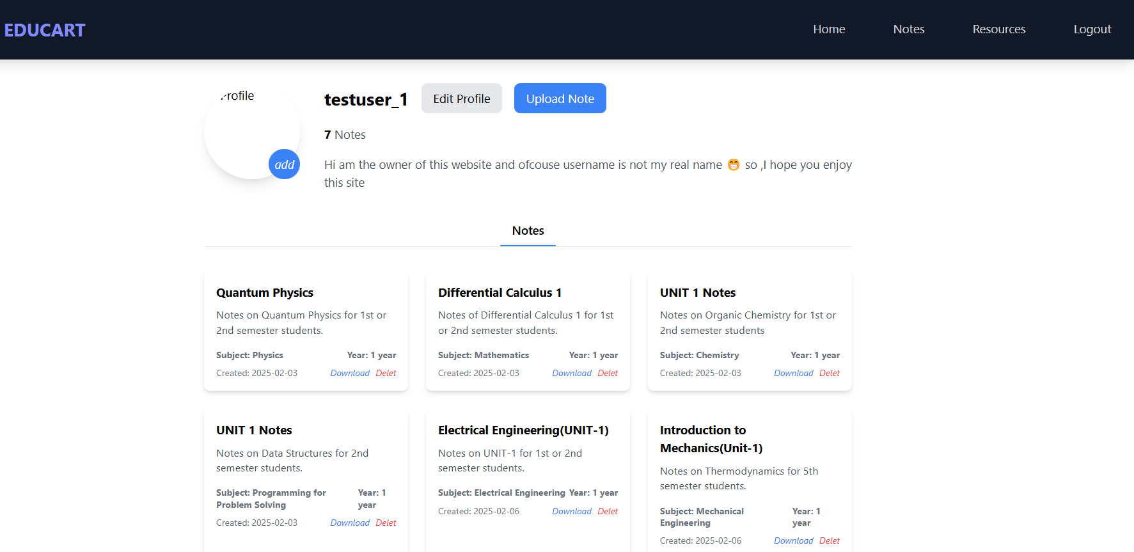

5. Technical Architecture

5.1 Technology Stack

Frontend

Tailwind CSS:

Why Use It:Tailwind is a utility-first CSS framework that allows for quick and efficient styling of web pages. It promotes consistency and maintainability in the codebase by using predefined classes.

- Benefits:

- Responsive Design: Tailwind makes it easier to create responsive designs that look great on different devices and screen sizes.

-Customizable: It offers extensive customization options, allowing developers to tweak the design according to specific needs.

-Efficiency: Reduces the need to write custom CSS, speeding up the development process.

Backend

Python

-Why Use It: Python is a versatile programming language known for its readability and simplicity. It's widely used for web development, data analysis, artificial intelligence, and more.

- Benefits:

- Ease of Use: Python’s syntax is easy to learn and understand, making development faster and more efficient.

- Rich Ecosystem: A vast number of libraries and frameworks, such as Django and Flask, support rapid development and integration.

- Scalability: Python is capable of handling small to large-scale projects with ease, ensuring the backend can grow with the application’s demands.

Database

MongoDB

- Why Use It: MongoDB is a NoSQL database known for its flexibility and scalability. It uses a document-oriented data model, which is ideal for handling diverse data types and structures.

- Benefits:

- Flexible Schema: Allows for dynamic schema design, accommodating various note types and metadata without requiring a rigid schema.

- Scalability: Can easily handle increasing amounts of data and users, making it suitable for growing applications.

- High Performance Efficiently processes and queries large volumes of data, ensuring a smooth user experience.

System Design Considerations

Scalability

- MongoDB's Role: MongoDB’s distributed architecture allows for horizontal scaling, meaning more servers can be added to accommodate increased load. This ensures the application can handle more users and data without compromising performance.

User Experience (UX)

- Tailwind's Role: Tailwind ensures that the website is responsive, meaning it adjusts seamlessly to different screen sizes and devices. This is crucial for providing a consistent and enjoyable user experience across desktops, tablets, and mobile phones.

6. Implementation Details

User Interface:
The site features a clean, modern interface that guides the user from the landing page through the sign-up/sign-in process and on to the notes repository.

Backend Services:
Python frameworks (such as Flask or Django) are leveraged to create RESTful APIs that manage user authentication, note uploads/downloads, and search queries.

Database Schema:
MongoDB stores user profiles, note metadata (e.g., subject, academic year), and the notes themselves. Its document-based structure allows for flexible and rapid development.

Testing and Deployment:
The project includes a testing phase to ensure functionality (e.g., testing search, upload, and deletion functions) before final deployment on a production server.

7. Project Results

Time Savings:
By consolidating study materials into one platform, students can access the information they need faster than searching multiple external sites.

User Engagement:
Early testing suggests that the ability to upload and manage personal notes encourages active participation and community contribution.

Scalability and Maintainability:
The chosen tech stack provides a robust foundation for future enhancements and can scale to accommodate growing user numbers and content volume.

8. Conclusion and Future Scope

Educart successfully addresses the need for a centralized, user-friendly platform for college students to share and access academic notes. The project has streamlined the process of locating study materials and encourages a collaborative learning environment.

Future Enhancements Could Include:

Mobile Application Development:
Creating a dedicated mobile app for easier on-the-go access.

Enhanced Search Features:
Incorporating advanced filtering (e.g., by professor or course level) to further refine search results.

Integration of Multimedia Content:
Allowing users to upload video lectures or interactive content alongside traditional notes.

Social Features:
Adding discussion forums or rating systems to help users identify the most helpful resources.

